**Assignment: Implement the Factory Method Pattern for Vehicle Creation**

#### **Problem Statement**

You are tasked with designing a **vehicle manufacturing system** using the **Factory Method Pattern**.

* Vehicles can be of different types:
  + Cars → CompactCar, SedanCar
  + Motorcycles → Scooter, SportBike
* Each vehicle should implement a common interface Vehicle with at least:

**void start();**

**void stop();**

* VehicleFactory should be the abstract class containing the method:

**public abstract Vehicle create(String type);**

**public void configureVehicle(String type, String color) { ... }**

* CarFactory should implement the factory to create CompactCar or SedanCar.
* MotorcycleFactory should implement the factory to create Scooter or SportBike.

#### **Tasks**

1. Implement the Vehicle interface and concrete product classes (CompactCar, SedanCar, Scooter, SportBike).
2. Implement the VehicleFactory abstract class and concrete factories (CarFactory, MotorcycleFactory).
3. In a Main class, write code to:
   1. Create a Sedan Car (color: Blue) using CarFactory.
   2. Create a Sport Bike (color: Red) using MotorcycleFactory.
   3. Start and stop both vehicles.

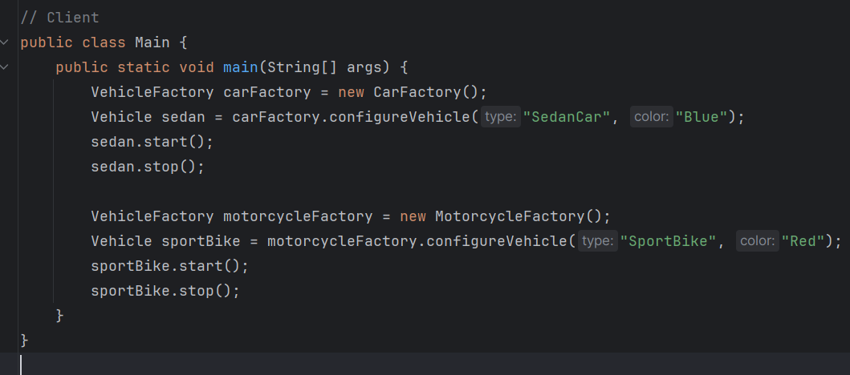

#### **Expected Output**



